ADITYA S 2116240701020
Experiment 1: Comparative Study of Low-Code Development versus Traditional Development Approaches

Aim
To perform a comparative study of Low-Code Development and Traditional Software Development by examining their development processes, architecture, advantages, limitations, implementation methods, and real-world applications.

Introduction to traditional approach
Software development has evolved significantly over the past few decades. Traditionally, software applications were built by writing every line of source code manually using programming languages such as Java, Python, C++, C#, or JavaScript. This method, known as Traditional Development, provides complete control over the application's architecture, business logic, security, and performance. However, it requires experienced developers, longer development cycles, and considerable investment in testing, deployment, and maintenance.
Introduction to Low Code
In contrast, Low-Code Development is a modern software development approach that simplifies application creation through visual interfaces, drag-and-drop components, reusable templates, and automated workflows. Instead of writing thousands of lines of code, developers configure application logic using graphical tools while adding custom code only when required. Popular low-code platforms include Zoho Creator, Microsoft Power Apps, Mendix, OutSystems, and Appian.

Development Process

Traditional Development Workflow
- Requirement Analysis
- System Design
- Database Design
- Coding
- Testing
- Deployment
- Maintenance

Diagram for stages in traditional approach..
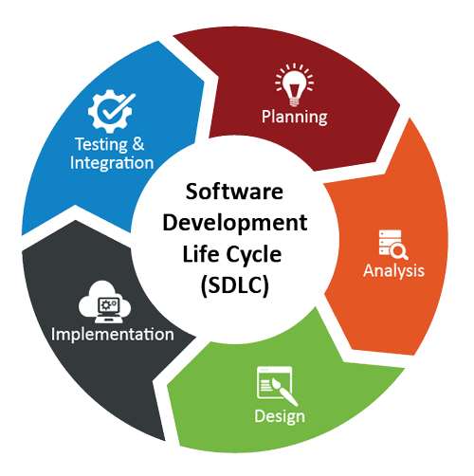

Low-Code Development Workflow
- Requirement Analysis
- Visual Interface Design
- Configure Business Logic
- Integrate Database and APIs
- Test the Application
- One-Click Deployment
- Continuous Monitoring and Updates

Diagram for steps in low code.
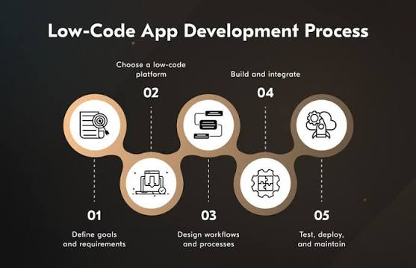

Comparative Analysis
Comparison Factor | Traditional Development | Low-Code Development
Development Speed | Slower due to manual coding | Faster through visual development
Coding Requirement | Complete manual programming | Minimal coding required
Development Cost | Higher because of skilled developers | Lower development cost
Learning Curve | Requires programming expertise | Easy for beginners and business users
User Interface Design | Created manually | Built using drag-and-drop components
Customization | Unlimited customization | Limited by platform capabilities
Performance | Excellent for complex systems | Good for standard business applications
Scalability | Highly scalable with proper architecture | Depends on platform limitations
Security | Fully controlled by developers | Managed partly by the platform provider
Deployment | Manual server configuration | Automated deployment
Database Management | Manual database design and optimization | Built-in database management
API Integration | Custom API implementation | Pre-built API connectors
Maintenance | Developer responsibility | Mostly managed by platform
Team Requirement | Software engineers, testers, DevOps | Smaller teams with citizen developers
Best Use Cases | Enterprise software, AI systems, banking, gaming | Business applications, workflow automation, dashboards, forms

Result

The study concludes that Low-Code Development is best suited for rapidly building business applications with reduced development time and cost, while Traditional Development is ideal for complex, high-performance, and highly customized software. The choice between the two depends on project requirements, budget, and scalability needs.

